I. Program Name: Monthly Salary

II. Program Description: Hands-on quiz

III. Input/Process/Output:

Input: None

Process: Calculating the total monthly salary of an employee

Output: Display the total monthly salary of an employee along with the rest of their work related information.

IV. Flowchart:

Calculating the total monthly salary of an employee

Display the total monthly salary of an employee along with the rest of their work-related information.

V. Source Code:

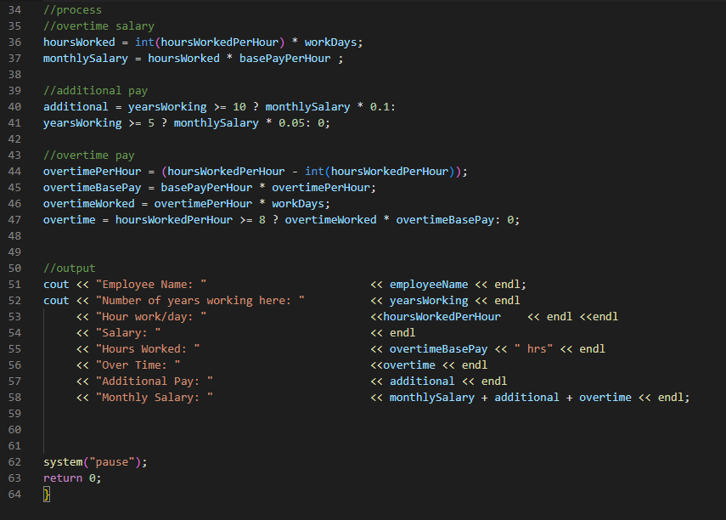

VI. Screenshot:

